**Trenchless pipe rehabilitation**

**ner**

## **Approved systems for trenchless sewer rehabilitation**

Efficient systems and components for trenchless renovations of house connection, collecting pipes or internal pipelines.

The advantages of pipe liner technologies are obvious: cost and time savings, reduced CO2 emissions and environmental sensitivity.

Processes are based on epoxy resin, the highest quality resin system available.

Quality, optimisation and innovation – that is what attached great importance to as a system supplier.

**Systems cover pipeline range DN 70 up to DN 400**

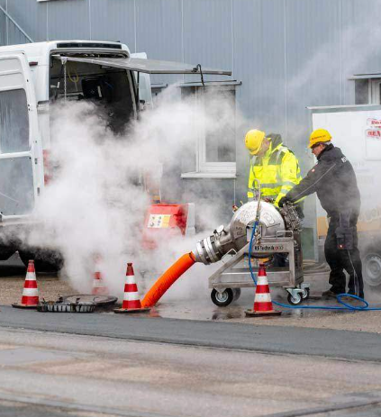

## **The all-rounder for pipeline rehabilitation**

System for trenchless rehabilitation of house connection pipes, collecting pipes and in-house pipes

With an extensive selection of carrier materials (pipe liners), resin systems andequipment for mixing, inversion and curing technology,

**Areas of application of the system:**

* House connection pipes
* Ground lines
* Pipelines inside buildings
* Drainpipes
* Connecting pipes in industrial and commercial enterprises

**Components with best properties**

Low reaction shrinkage, strong adhesion to the old pipe, maximum chemical resistance to waste water and proven good mechanical properties ensure that epoxy resin is the material of choice for house connections.

In addition, compared to other resin systems, no styrene is released during the curing reaction. Odour lessness is an important factor for customers.

**The advantages of the system:**

* Bend mobility
* Rehabilitation of up to four dimensional changes
* Renovations with an open end
* Renovations with difficult accessibility

## 

## **Pipe liner system for on-site renovation**

This is a worldwide used system for the installation of epoxy impregnated liners directly on the construction site in the range DN 150 to DN 800

Systems offer unique logistical advantages such as the preparation, impregnation and installation of epoxy impregnated liners directly on site. The system offers everything you need – resin and hardener tanks, mixing plant and calibration roller – it provides the necessary flexibility, the liner technology can be used almost anywhere and with any pipe type.

The system is ready for use at any time and is suitable for emergencies as well as for small or large construction sites.

Worldwide experience: the system has been in operation in Europe, Asia, the USA and Mexico for more than 25 years. Its efficiency and quality have been extensively tested.

**Properties**

* Mobile production through on-site impregnation with epoxy resin
* Airless mixing in pure resin flow with automatic dosing and mixing
* Complete measurement and documentation of the entire procedure
* Installation of the impregnated liner with the inversion method with hydrostatic head or pressure drum
* Hot water curing by circulation of hot water or steam
* Opening of laterals with cutter or robots

**Reliable system for the rehabilitation of manifolds**

A powerful system for the rehabilitation of manifolds. High reliability is guaranteed by the impregnation in the factory.

System is a liner technology used worldwide for manifolds with a diameter of DN 200 up to DN 1400 mm. This is a needle felt hose which is impregnated in the factory under controlled conditions with the polyester resin and delivered in a refrigerated transporter to the construction site.

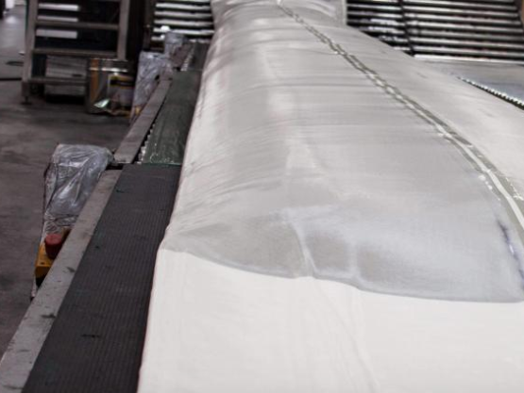 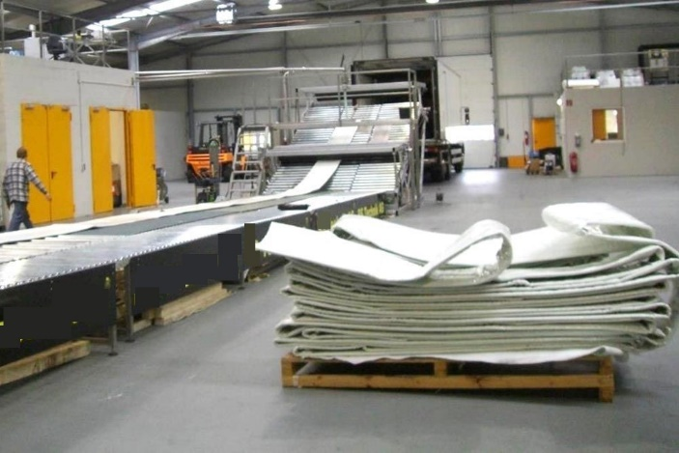

**A powerful system for the rehabilitation of manifolds. High reliability is guaranteed by the impregnation in the factory.**

**Properties of the system:**

* Factory wetting of the polyester needle felt hose under controlled conditions with polyester resin
* Temperature-controlled delivery to the construction site in a refrigerated truck
* Installation of the pre-impregnated liner directly from the vehicle
* Liner installation using a hydrostatic water column
* Documentation and protocol of the most important mixing and impregnation parameters
* Curing by the circulation of hot water
* Opening of lateral with cutter or robot

**Short sections** [**repair procedure**](https://rstechnik.com/en/systems/rs-maxpatch-short-liner-repair-procedure/)

A powerful short liner system for fast sealing and static stabilization of local damage. The partial repair method has proven itself in unpressurized wastewater

## **The repair procedure for all cases**

Together with the complete pipe lining rehabilitation systems. It is available for fast, trenchless and punctual repairs. a proven, on-site curing short liner system for the renewal of short sections in pressure less pipes from DN 100 to DN 800.

It cures at ambient temperatures with virtually no shrinkage and even under water. The resin ensures the best possible sealing of the defective pipe and eliminates the need for a pre liner and heating system.

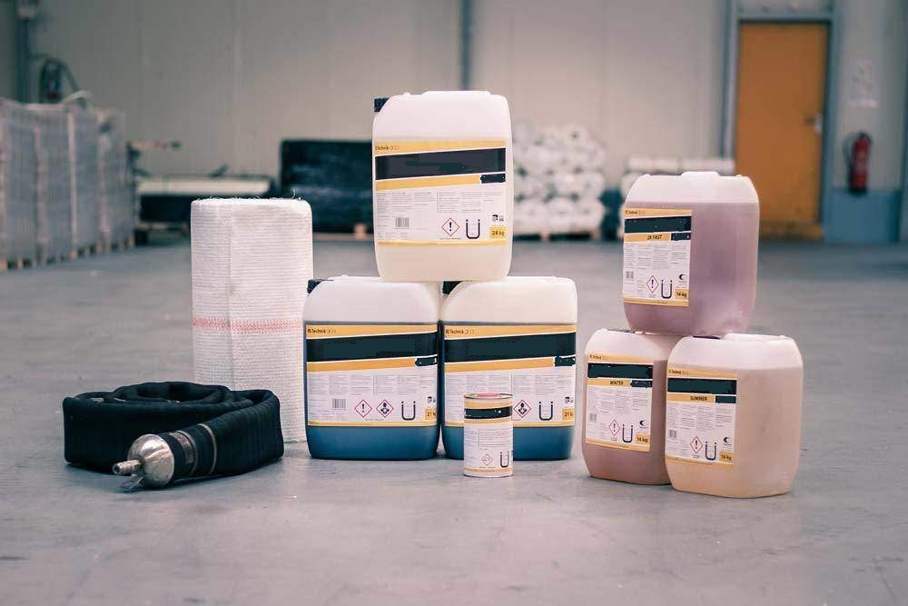

**Properties:**

* Fast, trenchless, selective repair process without time-consuming set-up work
* Elimination of leakages in exfiltration and infiltration
* bends up to 30° can be renovated
* Restores the load bearing capacity of damaged pipelines
* The use of different inflatable packers is possible

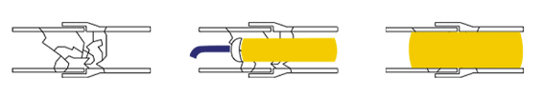

**Possible applications**

The corrosion-resistant glass fibre composite system is ideal for repairing and sealing minor pipe damage such as cracks, leaks and branch leaks or corrosion and root damage. The high-strength resin/glass fibre matrix offers a unique structural strength with an extremely slim profile, which helps not to obstruct the pipe flow and, in some cases, even improve it.

The system is based on a silicate resin system which is available as a three- and two-component system.

Non-foaming, elasticized three-component resin with good adhesion even to moist surfaces for bonding partial liners (short liners) during sewer rehabilitation.

* impregnates glass fibre mats or polyester fleeces well
* also adheres to damp surfaces
* does not foam, not even when water comes in
* hardens well in thin layers
* Formwork can be easily demoulded
* is resistant to aggressive water, acids and alkalis and does not saponify. supplied in three components. Component C is used to adjust the setting behaviour.